1. In Unity, you will need a Player sprite with a movement script already attached so it can be tested properly. Ensure that it has the Player tag assigned to it under the inspector tab. This will be used later in the script.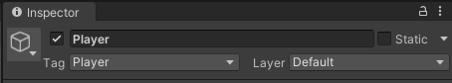
2. Create a new C# script and name it something relevant, such as CameraFollow, then open it.
3. First, create these two variables. The first will be used to set the speed of the camera, and the second will be assigned to the Player sprite so that the camera is attached to it.
4. Under void Update, write the lines below. The first line will set and update the target position of the camera using the target variable, and the second line is what will move the camera into that position. It calculates the speed of which this happens using the speed set above and Time.deltaTime, which is used to ensure there is no delay. 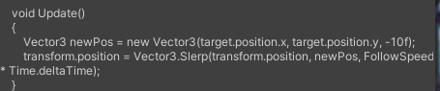
5. Save and return to Unity, then attach the script to the main camera and set the target to the Player sprite by dragging it from the hierarchy.